Fred Byrant: How the Keaton Otis Vigil Began
At the time Keaton Otis was killed by police, he was a kind, loving 25-year-old Black man – a son, grandson, brother, father and good friend. On May 12, 2010 he happened to be driving his mother’s car while wearing a hoodie. Portland gang enforcement team spotted him and radioed in that they were going to follow him because, "He was wearing a hoodie… He kind of looks like he could be a gangster.”
Witnesses say Keaton had pleaded for help — “don’t leave… they’re gonna kill me”— as officers lined up along one side of his car. Video footage of the murder recorded Keaton screaming that he had his hands up right before a police officer shouts, "Let's do it!" and the three officers open fire. Within 3 minutes of being pulled over, Keaton had been punched in the face through the car window, tased twice in the neck, and shot 23 times in a seven-second barrage of 32 shots.
Keaton's body was left in the street for hours.
In response to this unjust murder, Keaton’s Father, Fred Bryant, called a vigil at the intersection where his son was murdered the next 12th of the month. At it, through tears, he vowed he would be at that spot every 12th of the month until there was justice for Keaton. For more than 3 years, he was out there - in the snow, in torrential rain, in blistering heat - never missing a single month.
Fred developed severe heart problems, and his doctor told him to take it easy and reduce stress, or he could die. Fred replied, "Then I'm going to die, because I won't stop until there is justice for my son." Fred suffered a severe stroke and passed away Oct. 29, 2013. One community member who knew Fred from the vigils said, “He died of a broken heart”, and “The police killed two people that day”.
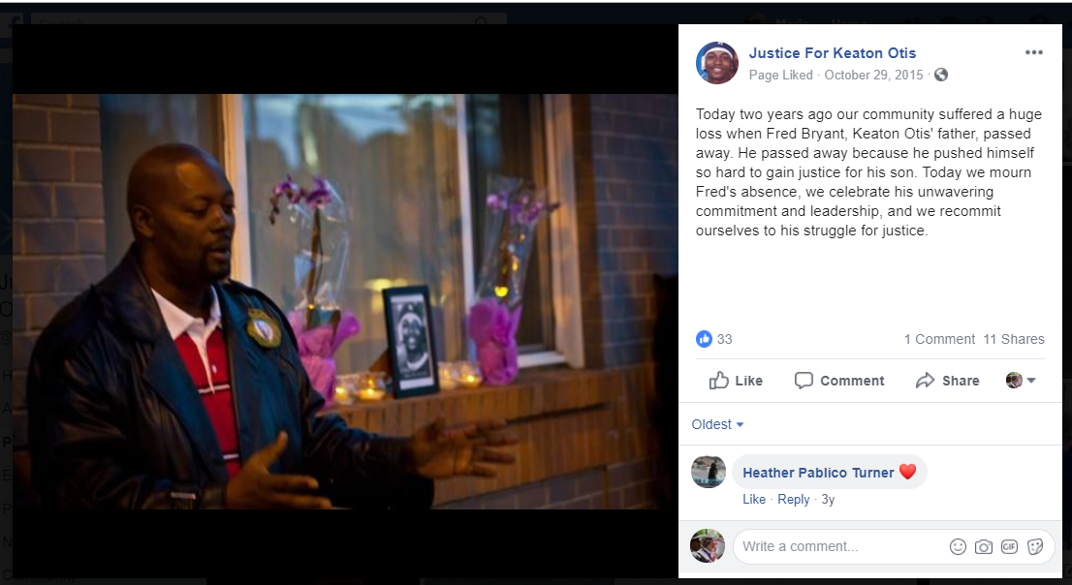
Fred Bryant is pictured, two years after his untimely death, speaking at the intersection of NE 6th and Halsey in Portland, Oregon where his son, 24-year old Keaton Otis, was killed by police.
But because of Fred's immense spirit and boundless love for his son and for his community, the community pulled together and continued the monthly Justice for Keaton Otis vigils in Fred's name. They continue to this day, 8.5 years after the start. There has never been one month when the vigils have not happened. A reporter once asked one of the organizers, "There are so many police shootings every year - what makes this situation different? Why is this one of the longest running ongoing vigils for someone murdered by the police?" The organizer replied, "The one difference is Fred Bryant. He rose to be a community leader through this tragedy, and his determination and commitment to justice for his son and for all those murdered by police carries us through. Fred had enough love and determination to carry this event forward even after his death."
So every month, community members continue to gather for one hour to mourn Keaton’s death and celebrate his life. And the family members of others who have lost loved ones to police violence have kept it a space to remember the humanity of those gone, so they will never be just names and faces on posters but are remembered as real people who will forever be missed. Some come to network and organize. Others come for inspiration and to renew their commitment to pursuing police accountability. Others, especially family members who’ve also lost loved ones to police violence, come for the support. All come to honor Keaton Otis and Fred Bryant.
Mr. Byrant made a place for us all. We will not forget the great commitment he had to uniting the community to get justice for his son and #AllStolenLives.
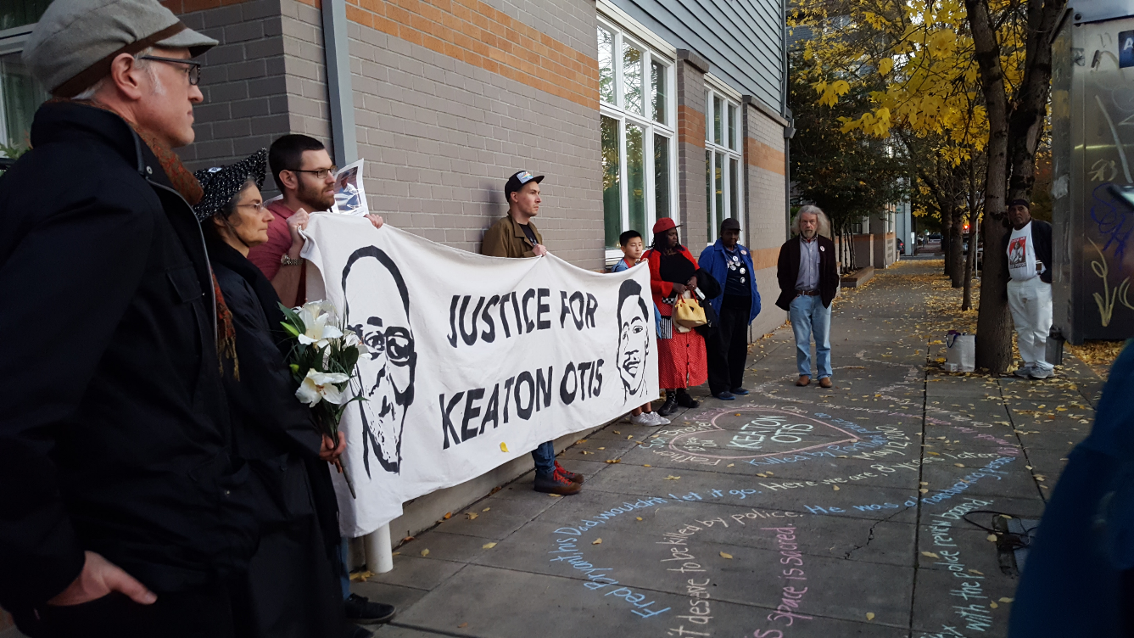
October 12, 2018. 8.5 years after Keaton Oti’s death, and 5.5 years after Fred Bryant’s death, the community continues to gather every month. Telling the story of this son and father. (Mr. Bryant is pictured on the left side of the banner. Mr. Otis is on the right.)

